double ang = Math.PI / 2.25;
double T[] = {Math.cos(ang), -Math.sin(ang), 10, Math.sin(ang), Math.cos(ang), 5};
0.0013196690425428114 [1.3963552836650537, 10.003738393366259, 5.001809558912119, ]
40% de los puntos con varianza 10 y el 60% con varianza 0

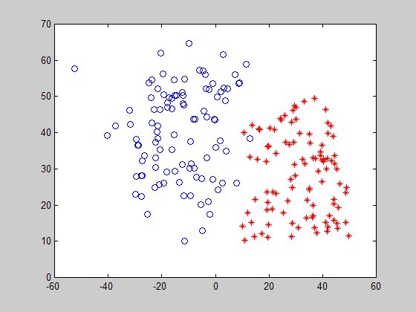

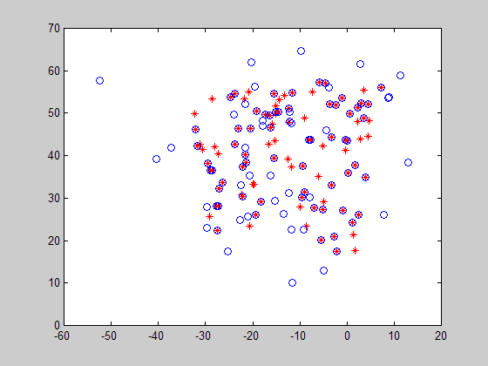
double ang = Math.PI / 2.25;
double T[] = {Math.cos(ang), -Math.sin(ang), 10, Math.sin(ang), Math.cos(ang), 5};

0.35236602780499776 [1.3952877116281859, 10.04359934819349, 4.813161055223247, ]
40% de los puntos con varianza 10 y el 60% con varianza 1

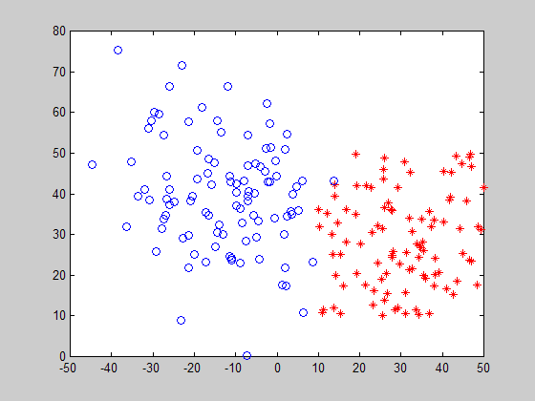

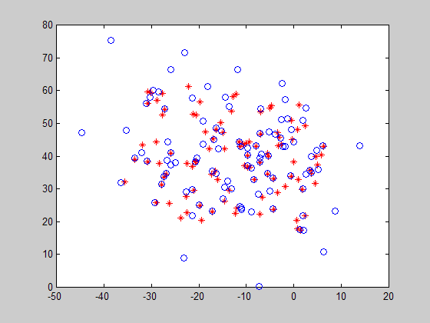
Punto Inicial 2000.0 2000.0 45.0
Punto Final 2777.8 2777.8 45.0

19.945188350920862 [5.340656627239259E-4, -1105.0462111511713, -1.715080464084339, ]

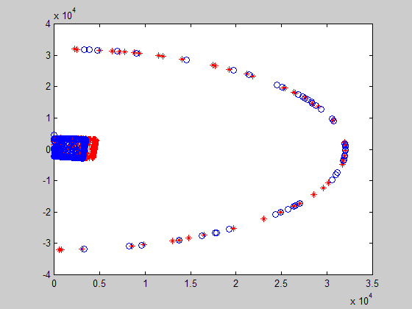

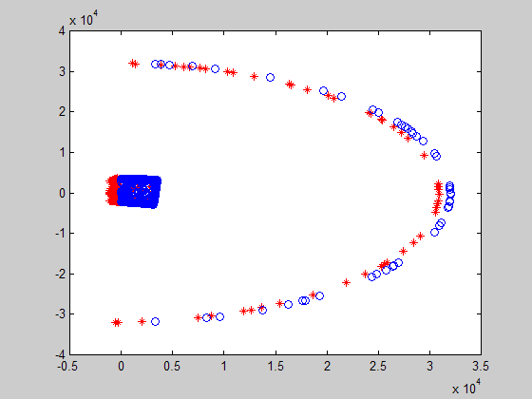
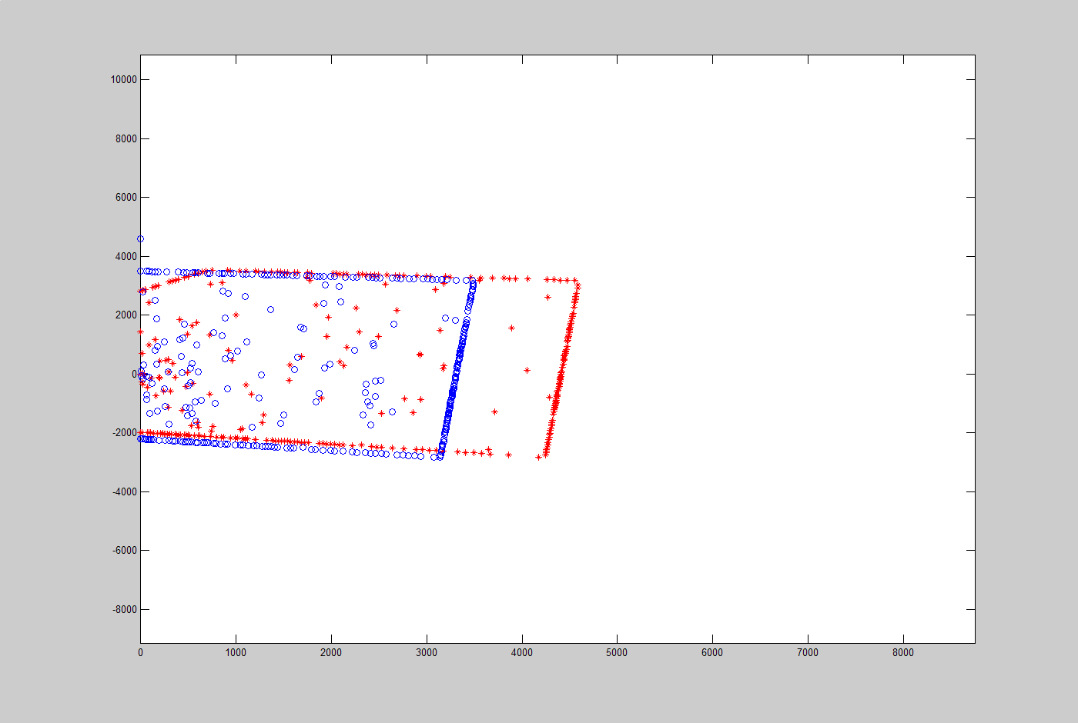

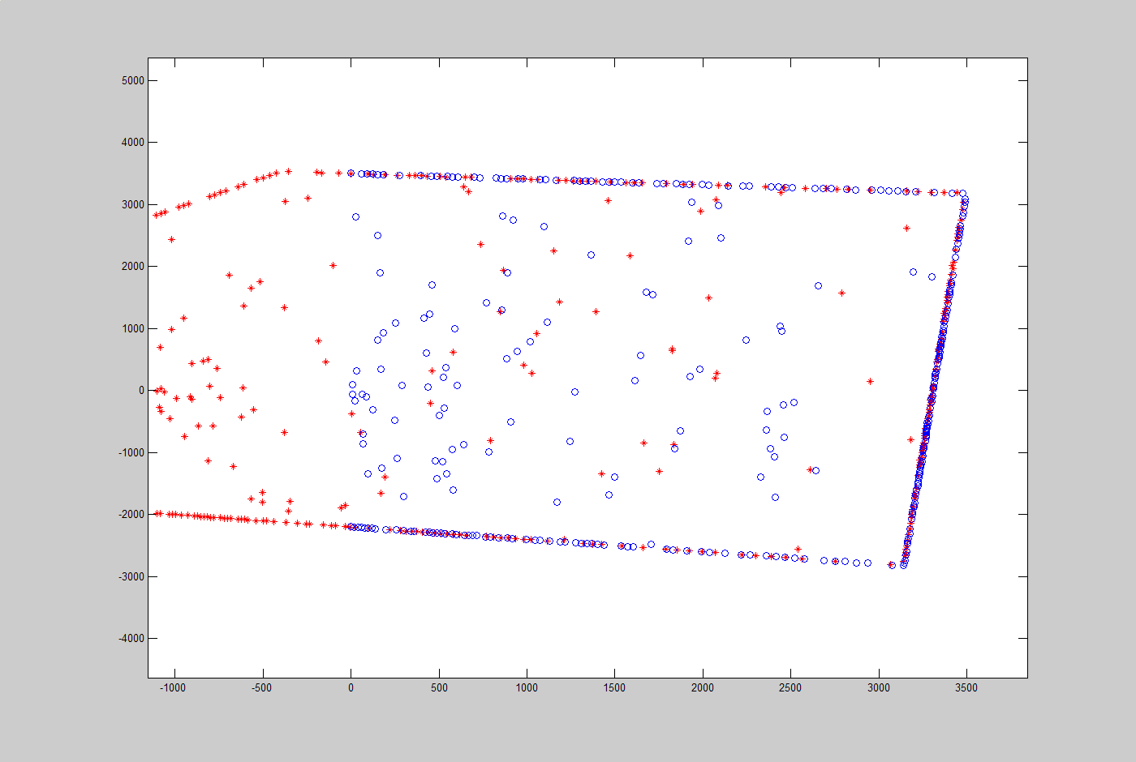
Punto inicial 3000.0 3000.0 0.0
Punto Final 3000.0 3000.0 15.0
5.581317321700453 [-0.2617260820585739, -0.3351419378588907, -0.43782691522624784, ]

